Non-Linear PowerPoint 2007 Presentation Tutorial

1. Open PowerPoint on your computer.

2. Make sure you have a new presentation open. Type a title for your PowerPoint in the Title text box.

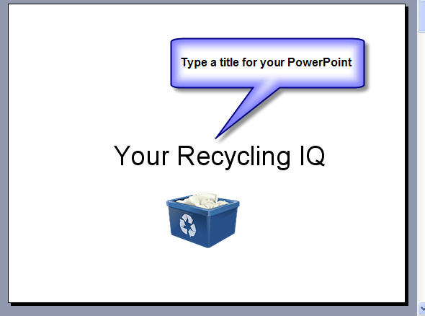

3. From the Home tab, click New Slide to create a new slide. Select the type of slide you would like to use from the drop down menu.

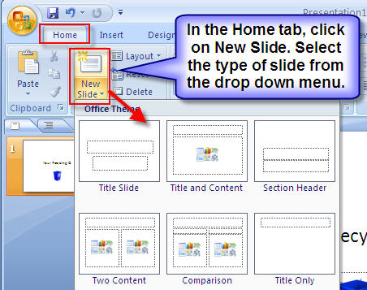
4. On the new slide, choose the slide layout of your choice and then type the first question and available answers.

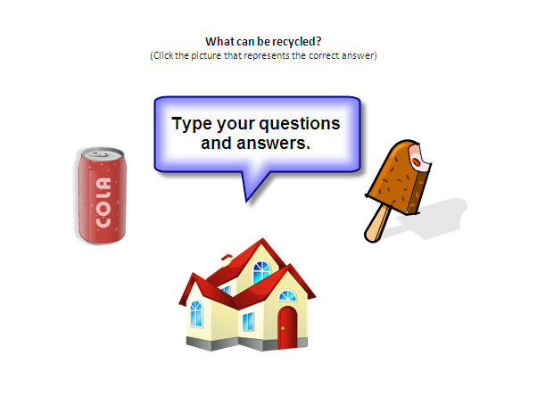

5. Click New Slide to create a new slide.

6. Create a Correct Answer Slide.

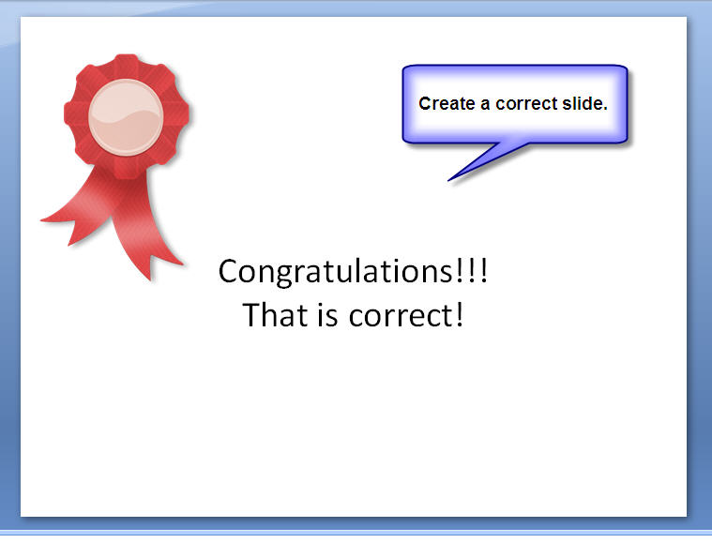

7. Click New Slide to create a new slide.

8. Create a Wrong Answer Slide.

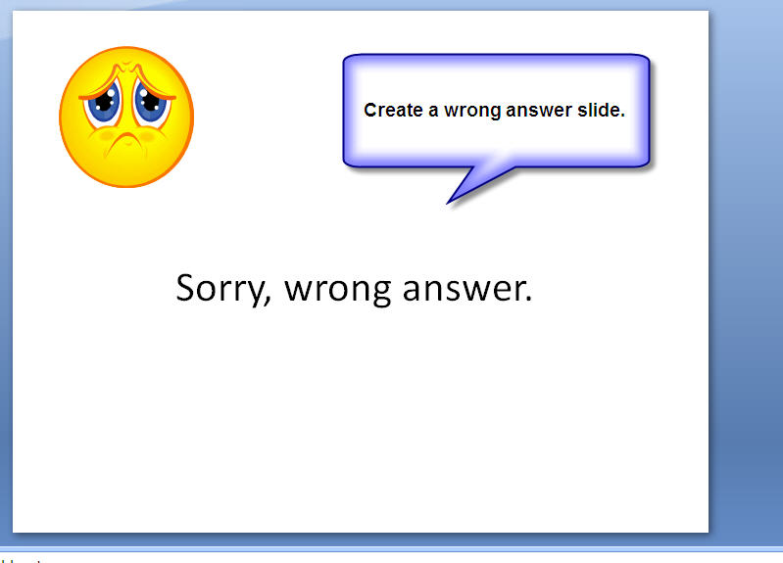

9. Click New Slide to create a new slide.

10. Create a Finished Slide.

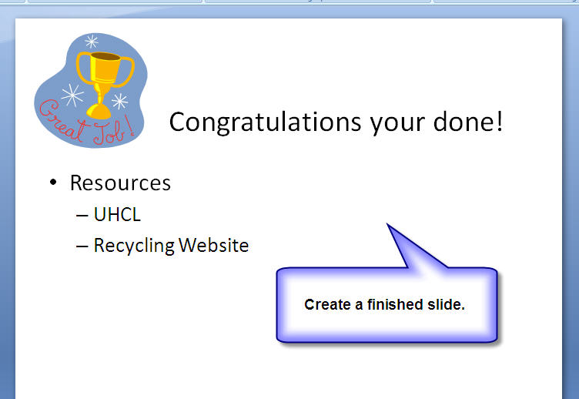

11. Click on your question slide.

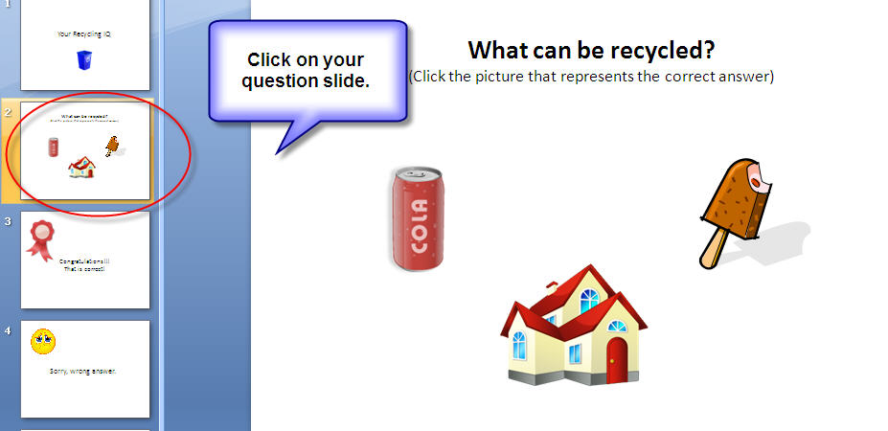

12. Click on a correct answer. It can be a picture or text depending on how you set up your answers. For this example I am using pictures.

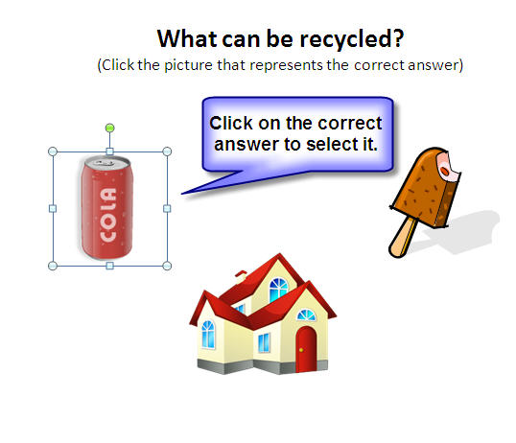

13. Click the Insert tab and then Action. The Action Settings pop up box will open up. For Action on Click select Hyperlink to and then select the correct answer slide. (It may be the next slide, last slide, previous slide, ect.)
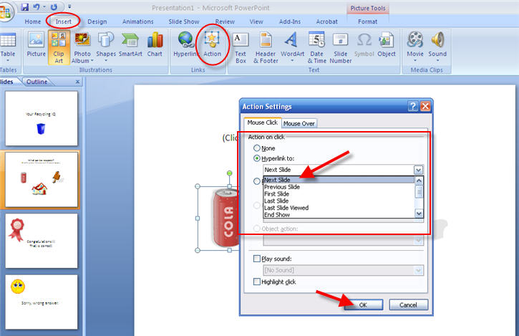

14. If you click the down arrow you will get more options. Select the Slide option.

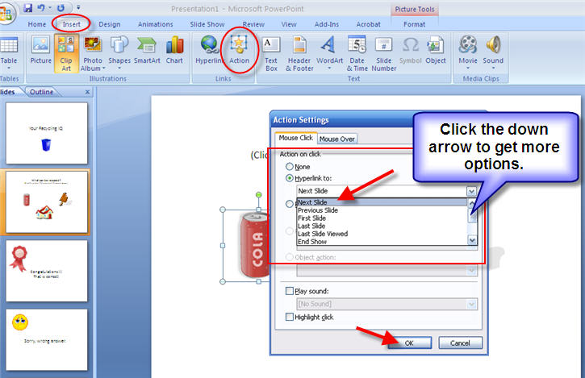

15. You be given a pop up with a list of all your slides. Click the correct slide. Click OK.

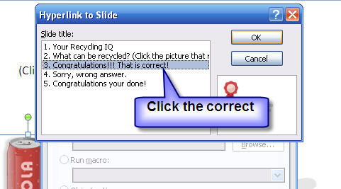

16. Click on the wrong answer. It can be a picture or text depending on how you set up your answers. For this example I am using pictures.

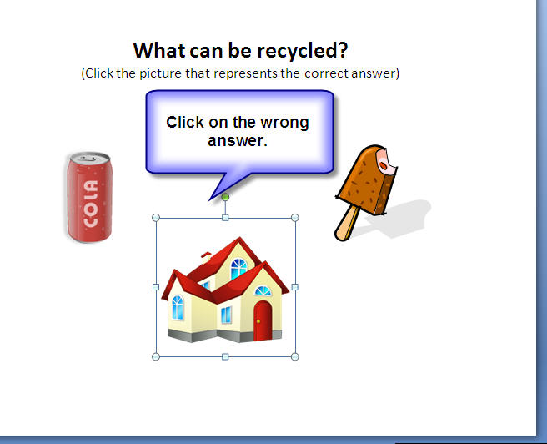

17. Click the Insert tab and then Action. The Action Settings pop up box will open up. For Action on Click select Hyperlink to and then select the correct answer slide. (It may be the next slide, last slide, previous slide, ect.) If you click the down arrow you will get more options. Select the Slide option. You be given a pop up with a list of all your slides. Click the wrongt slide. Click OK.
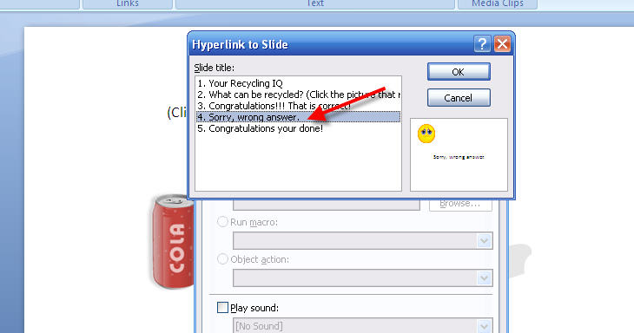

(Repeat steps 12-17 for the rest of your answers)

How to Add Action Buttons

18. Click on your correct answer slide. Click the Insert tab. Click Shapes and scroll down to the Action Buttons and select the Forward or Next button.

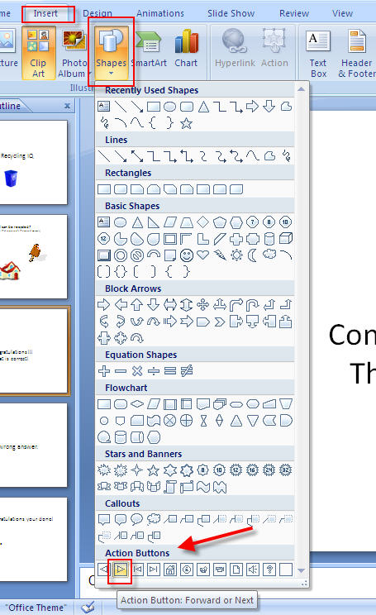

19. A crossbar will appear on the slide. Place it on the slide where you want the button to appear then left click the mouse and pull down to draw the button.

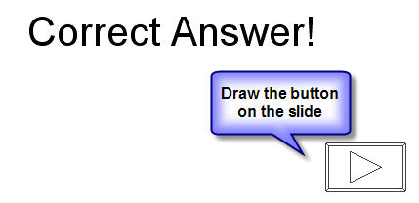

Example: Forward or Next Button

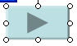

20. The Action Settings pop up box will open up. Click the scroll down arrow and select slide. The Hyperlink to Slide pop up box will open. Select the Congratulations slide. Click Ok, and then Click Ok again.

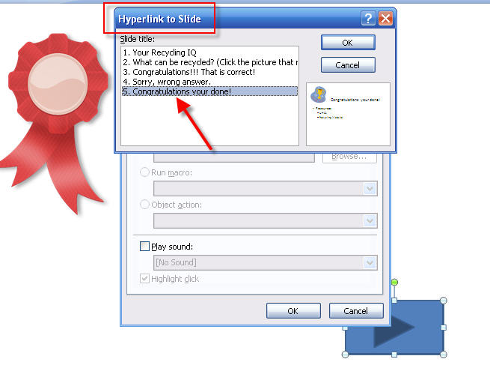

21. Click on your wrong answer slide. Click the Insert tab. Click Shapes and scroll down to the Action Buttons and select the Back or Previous button.

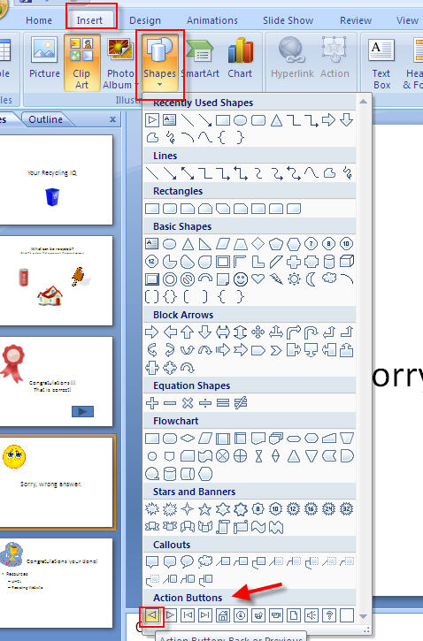

22. A crossbar will appear on the slide. Place it on the slide where you want the button to appear then left click the mouse and pull down to draw the button.

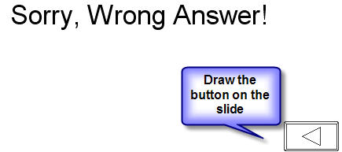

Example: Back or Previous Button

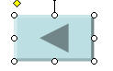
23. The Action Settings pop up box will open up. Click the scroll down arrow and select slide. The Hyperlink to Slide pop up box will open. Select the Question slide. Click Ok, and then Click Ok again.

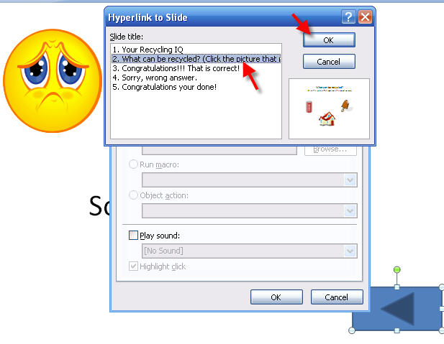

How to Add a URL

24. Click on your finished slide.



25. Highlight the text you want to open a URL for.

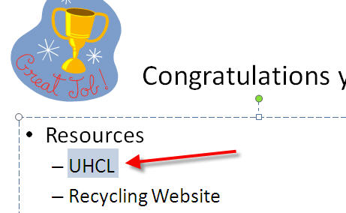

26. Click the Insert tab and then Hyperlink from the menu bar.

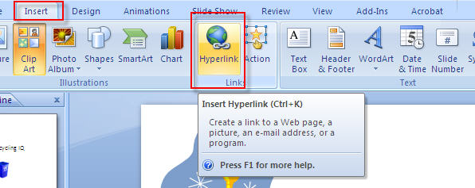

27. Type the URL you want to link to in the text box next to Address. Click OK.

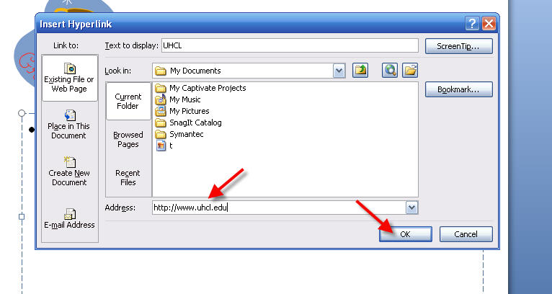

28. The text will now be underlined and a different color to indicate it is linked.

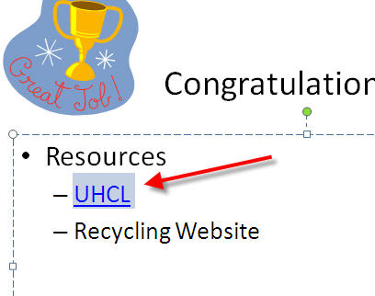

29. Save your PowerPoint presentation and test it out.

